|  |  |  |
| --- | --- | --- |
| Лабораторная работа №3  Проектирование базы данных | Ф.И.О. | Синкевич Д. А. |
| Группа | ПРИН-366 |
| Преподаватель | Соколов А.А. |
| Дата сдачи |  |

**Часть 1:**

1. Для реализации данный БД была выбрана графическая оболочка mysql workbench.

Перенесем реляционную схему из второй лабораторной и по ней с помощью reverse engineer сформируем код mysql. В ходе улучшение реализации идей были предприняты сл. действия: все типы переменных set заменены на enum; были доработаны обязательные и не обязательные поля в таблицах.

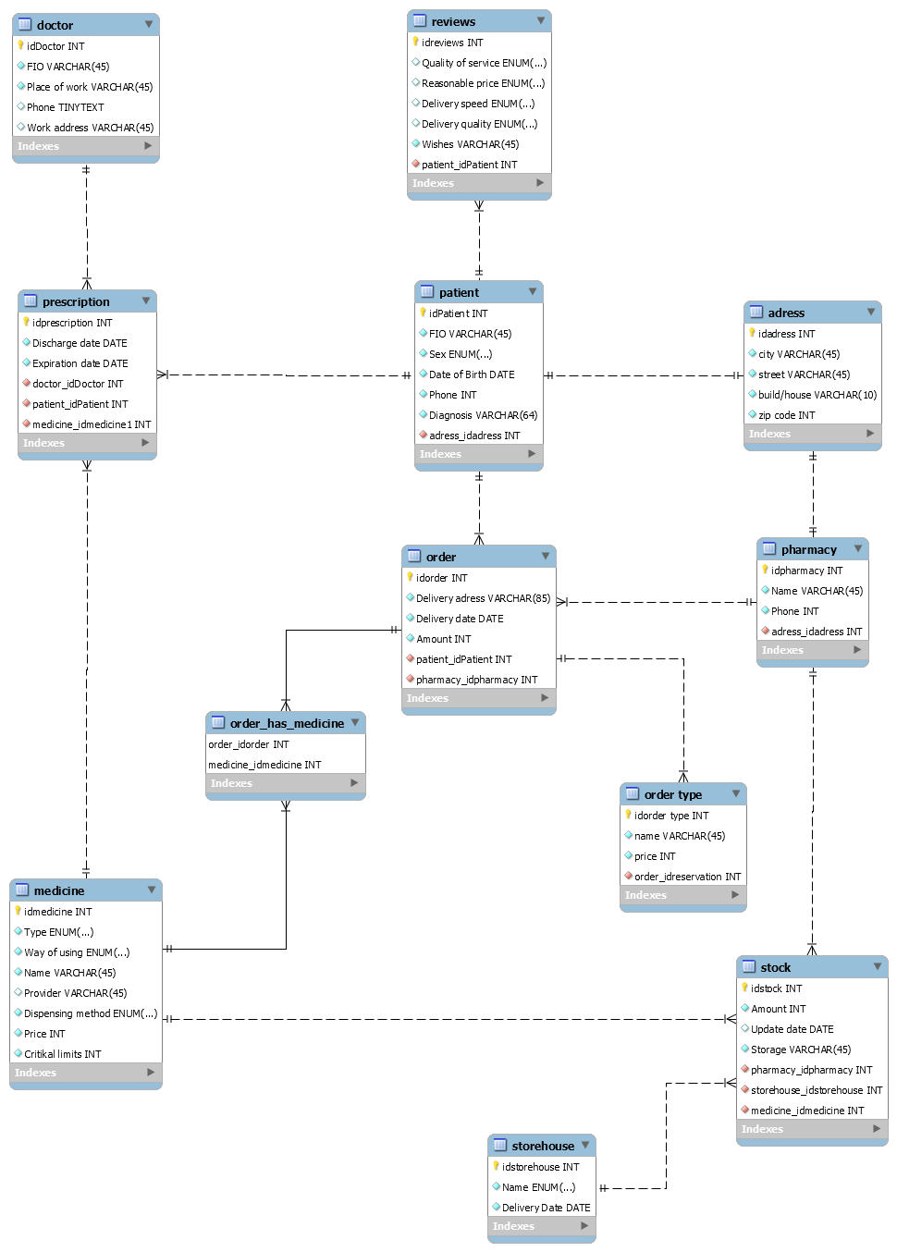

1. Реляционная модель

Создаем БД синхронизируя модель с помощью инструмента Synchronize model.

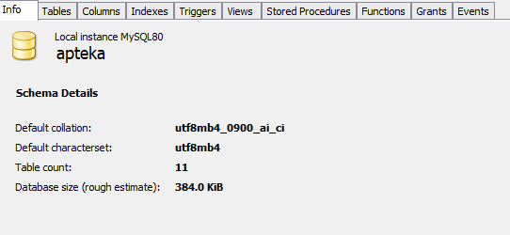

Заполним таблицы данными:

1. Address

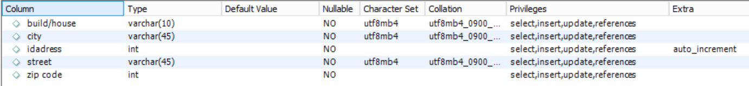

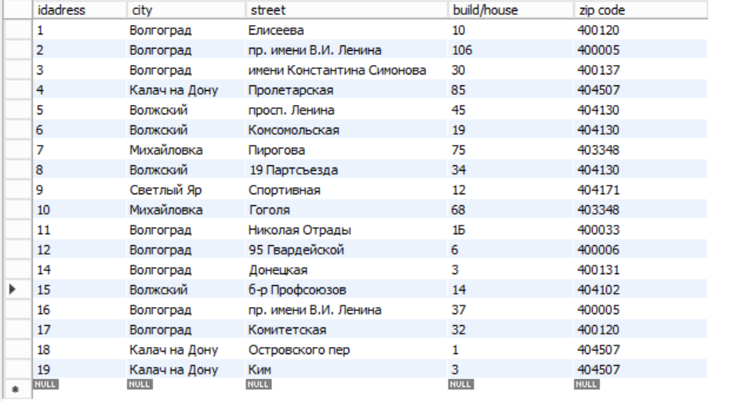

1. Patient

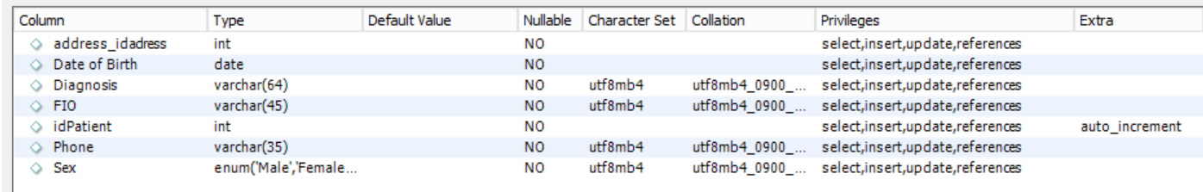

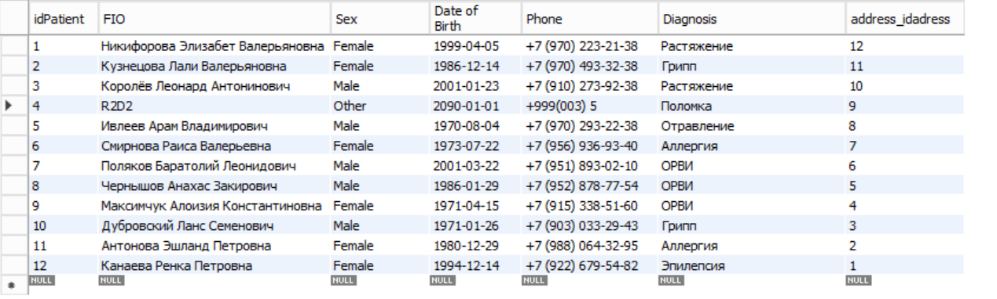

1. Reviews

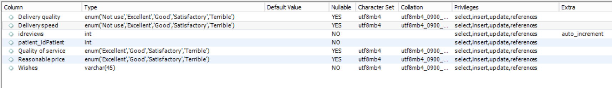

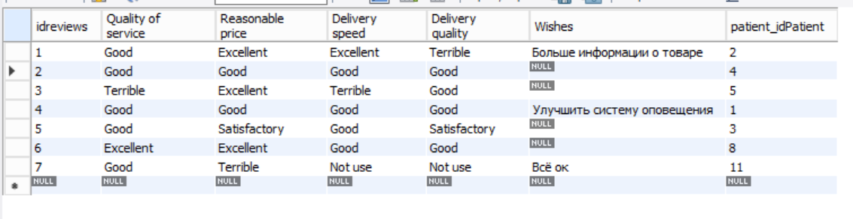

1. Storehouse

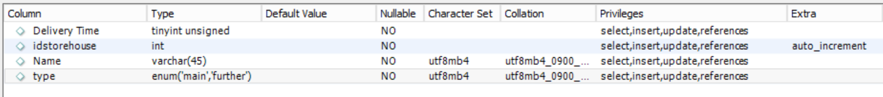

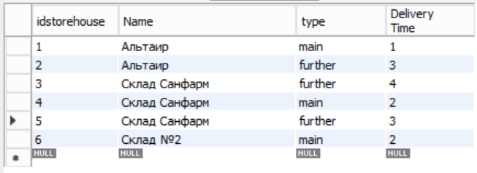

1. Doctor

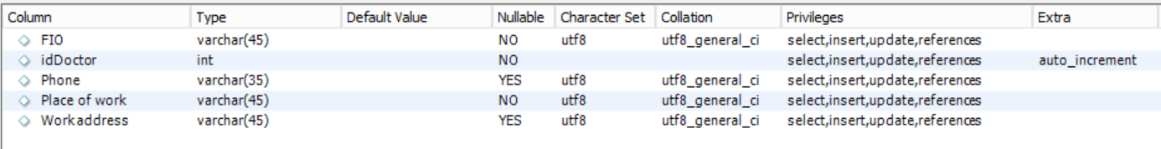

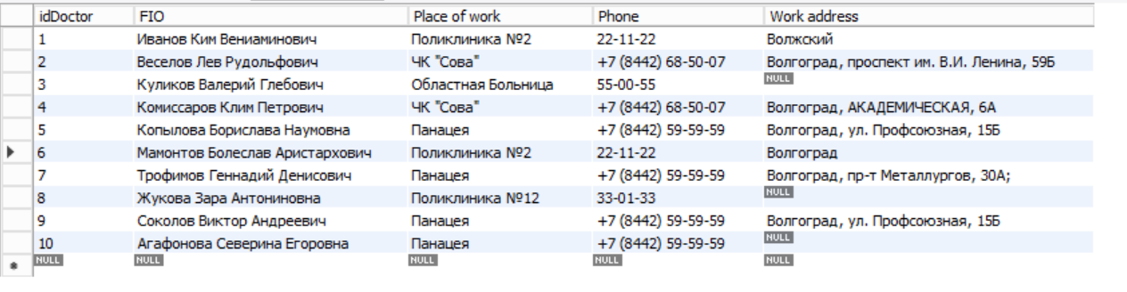

1. Pharmacy

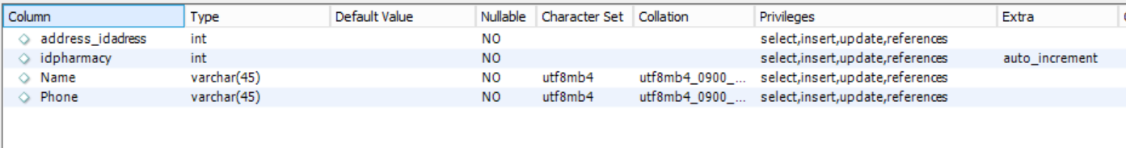

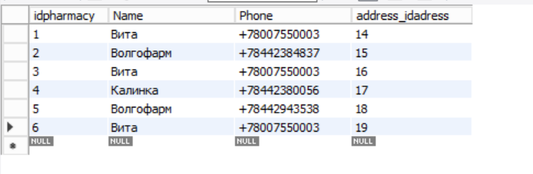

1. Medicine

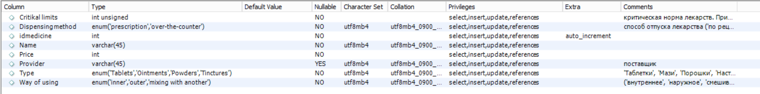

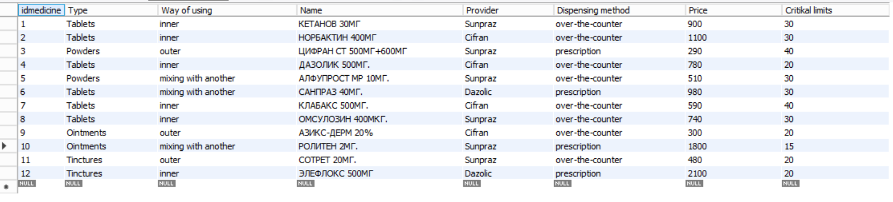

1. Prescription

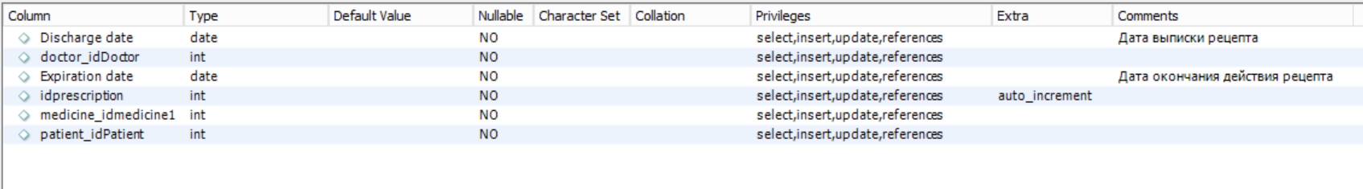

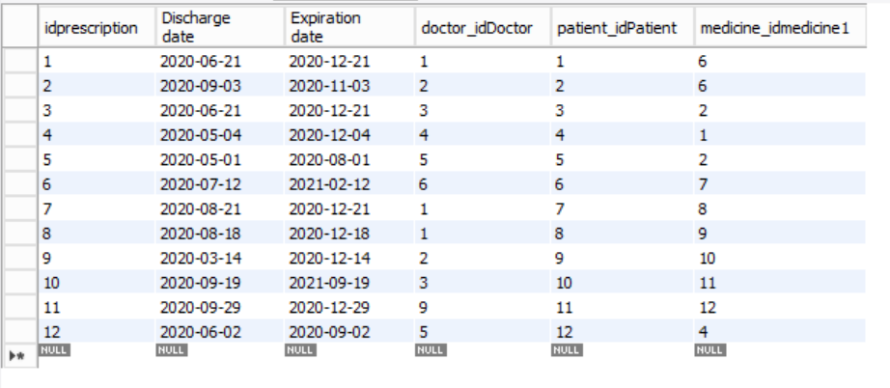

1. Stock

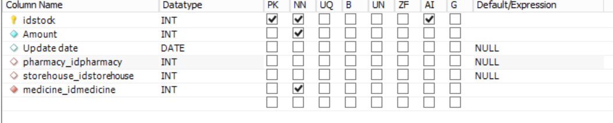

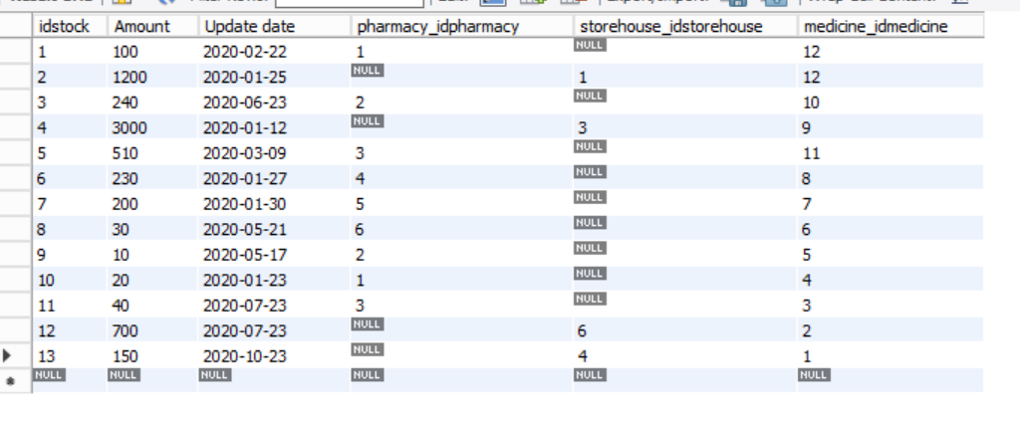

1. Order

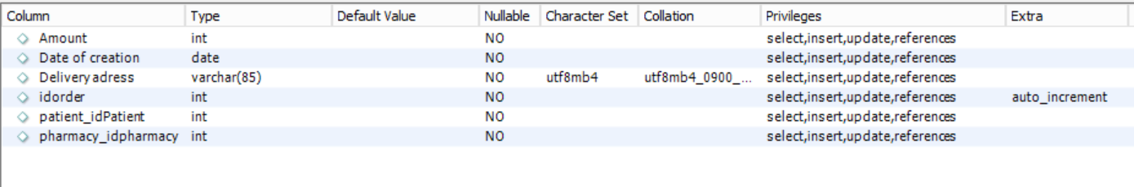

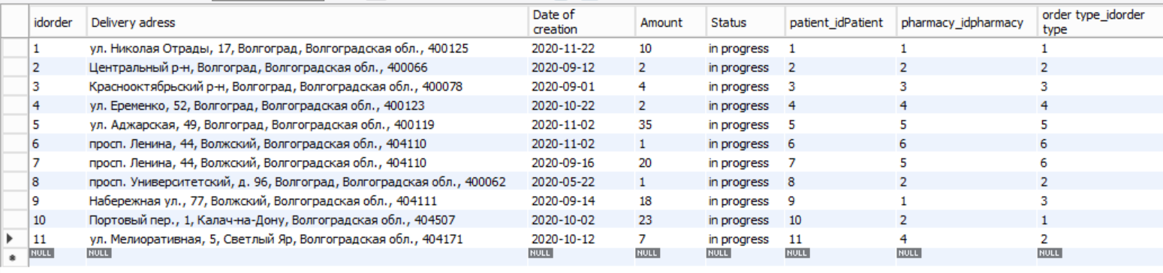

1. Order type

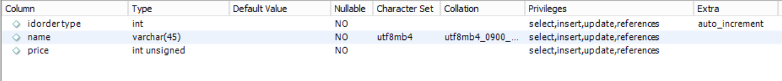

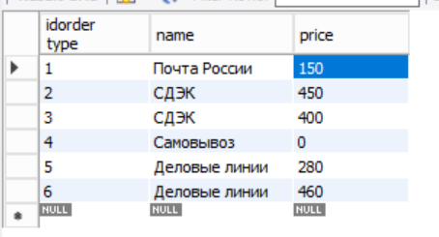

Код sql:

-- MySQL Workbench Forward Engineering

SET @OLD_UNIQUE_CHECKS=@@UNIQUE_CHECKS, UNIQUE_CHECKS=0;

SET @OLD_FOREIGN_KEY_CHECKS=@@FOREIGN_KEY_CHECKS, FOREIGN_KEY_CHECKS=0;

SET @OLD_SQL_MODE=@@SQL_MODE, SQL_MODE='ONLY_FULL_GROUP_BY,STRICT_TRANS_TABLES,NO_ZERO_IN_DATE,NO_ZERO_DATE,ERROR_FOR_DIVISION_BY_ZERO,NO_ENGINE_SUBSTITUTION';

-- -----------------------------------------------------

-- Schema mydb

-- -----------------------------------------------------

-- -----------------------------------------------------

-- Schema apteka

-- -----------------------------------------------------

-- -----------------------------------------------------

-- Schema apteka

-- -----------------------------------------------------

CREATE SCHEMA IF NOT EXISTS `apteka` DEFAULT CHARACTER SET utf8mb4 COLLATE utf8mb4_0900_ai_ci ;

USE `apteka` ;

-- -----------------------------------------------------

-- Table `apteka`.`address`

-- -----------------------------------------------------

CREATE TABLE IF NOT EXISTS `apteka`.`address` (

`idadress` INT NOT NULL AUTO_INCREMENT,

`city` VARCHAR(45) NOT NULL,

`street` VARCHAR(45) NOT NULL,

`build/house` VARCHAR(10) NOT NULL,

`zip code` INT NOT NULL,

PRIMARY KEY (`idadress`))

ENGINE = InnoDB

AUTO_INCREMENT = 20

DEFAULT CHARACTER SET = utf8mb4

COLLATE = utf8mb4_0900_ai_ci;

-- -----------------------------------------------------

-- Table `apteka`.`doctor`

-- -----------------------------------------------------

CREATE TABLE IF NOT EXISTS `apteka`.`doctor` (

`idDoctor` INT NOT NULL AUTO_INCREMENT,

`FIO` VARCHAR(45) NOT NULL,

`Place of work` VARCHAR(45) NOT NULL,

`Phone` VARCHAR(35) NULL DEFAULT NULL,

`Work address` VARCHAR(45) NULL DEFAULT NULL,

PRIMARY KEY (`idDoctor`))

ENGINE = InnoDB

AUTO_INCREMENT = 13

DEFAULT CHARACTER SET = utf8

COMMENT = 'Врач';

-- -----------------------------------------------------

-- Table `apteka`.`medicine`

-- -----------------------------------------------------

CREATE TABLE IF NOT EXISTS `apteka`.`medicine` (

`idmedicine` INT NOT NULL AUTO_INCREMENT,

`Type` ENUM('Tablets', 'Ointments', 'Powders', 'Tinctures') NOT NULL COMMENT '\'Таблетки\', \'Мази\', \'Порошки\', \'Настойки\'',

`Way of using` ENUM('inner', 'outer', 'mixing with another') NOT NULL COMMENT '(\'внутреннее\', \'наружное\', \'смешивание с другим\')',

`Name` VARCHAR(45) NOT NULL,

`Provider` VARCHAR(45) NULL DEFAULT NULL COMMENT 'поставщик',

`Dispensing method` ENUM('prescription', 'over-the-counter') NOT NULL COMMENT 'способ отпуска лекарства (\'по рецепту\', \'без рецепта\')',

`Price` INT NOT NULL,

`Critikal limits` INT UNSIGNED NOT NULL COMMENT 'критическая норма лекарств. При критической норме формируется заказ на производство или доставку\\\\n',

PRIMARY KEY (`idmedicine`))

ENGINE = InnoDB

AUTO_INCREMENT = 13

DEFAULT CHARACTER SET = utf8mb4

COLLATE = utf8mb4_0900_ai_ci

COMMENT = 'лекарство';

-- -----------------------------------------------------

-- Table `apteka`.`order type`

-- -----------------------------------------------------

CREATE TABLE IF NOT EXISTS `apteka`.`order type` (

`idorder type` INT NOT NULL AUTO_INCREMENT,

`name` VARCHAR(45) NOT NULL,

`price` INT UNSIGNED NOT NULL,

PRIMARY KEY (`idorder type`))

ENGINE = InnoDB

AUTO_INCREMENT = 7

DEFAULT CHARACTER SET = utf8mb4

COLLATE = utf8mb4_0900_ai_ci;

-- -----------------------------------------------------

-- Table `apteka`.`patient`

-- -----------------------------------------------------

CREATE TABLE IF NOT EXISTS `apteka`.`patient` (

`idPatient` INT NOT NULL AUTO_INCREMENT,

`FIO` VARCHAR(45) NOT NULL,

`Sex` ENUM('Male', 'Female', 'Other') NOT NULL,

`Date of Birth` DATE NOT NULL,

`Phone` VARCHAR(35) NOT NULL,

`Diagnosis` VARCHAR(64) NOT NULL,

`address_idadress` INT NOT NULL,

PRIMARY KEY (`idPatient`),

INDEX `fk_patient_address1_idx` (`address_idadress` ASC) VISIBLE,

CONSTRAINT `fk_patient_address1`

FOREIGN KEY (`address_idadress`)

REFERENCES `apteka`.`address` (`idadress`))

ENGINE = InnoDB

AUTO_INCREMENT = 13

DEFAULT CHARACTER SET = utf8mb4

COLLATE = utf8mb4_0900_ai_ci

COMMENT = 'Пациент';

-- -----------------------------------------------------

-- Table `apteka`.`pharmacy`

-- -----------------------------------------------------

CREATE TABLE IF NOT EXISTS `apteka`.`pharmacy` (

`idpharmacy` INT NOT NULL AUTO_INCREMENT,

`Name` VARCHAR(45) NOT NULL,

`Phone` VARCHAR(45) NOT NULL,

`address_idadress` INT NOT NULL,

PRIMARY KEY (`idpharmacy`),

INDEX `fk_pharmacy_address1_idx` (`address_idadress` ASC) VISIBLE,

CONSTRAINT `fk_pharmacy_address1`

FOREIGN KEY (`address_idadress`)

REFERENCES `apteka`.`address` (`idadress`))

ENGINE = InnoDB

AUTO_INCREMENT = 7

DEFAULT CHARACTER SET = utf8mb4

COLLATE = utf8mb4_0900_ai_ci;

-- -----------------------------------------------------

-- Table `apteka`.`order`

-- -----------------------------------------------------

CREATE TABLE IF NOT EXISTS `apteka`.`order` (

`idorder` INT NOT NULL AUTO_INCREMENT,

`Delivery adress` VARCHAR(85) NOT NULL,

`Date of creation` DATE NOT NULL,

`Amount` INT NOT NULL,

`Status` ENUM('in progress', 'done') NOT NULL,

`patient_idPatient` INT NOT NULL,

`pharmacy_idpharmacy` INT NOT NULL,

`order type_idorder type` INT NOT NULL,

PRIMARY KEY (`idorder`),

INDEX `fk_reservation_patient1_idx` (`patient_idPatient` ASC) VISIBLE,

INDEX `fk_reservation_pharmacy1_idx` (`pharmacy_idpharmacy` ASC) VISIBLE,

INDEX `fk_order_order type1_idx` (`order type_idorder type` ASC) VISIBLE,

CONSTRAINT `fk_order_order type1`

FOREIGN KEY (`order type_idorder type`)

REFERENCES `apteka`.`order type` (`idorder type`),

CONSTRAINT `fk_reservation_patient1`

FOREIGN KEY (`patient_idPatient`)

REFERENCES `apteka`.`patient` (`idPatient`),

CONSTRAINT `fk_reservation_pharmacy1`

FOREIGN KEY (`pharmacy_idpharmacy`)

REFERENCES `apteka`.`pharmacy` (`idpharmacy`))

ENGINE = InnoDB

AUTO_INCREMENT = 13

DEFAULT CHARACTER SET = utf8mb4

COLLATE = utf8mb4_0900_ai_ci

COMMENT = 'Резервирование лекарства';

-- -----------------------------------------------------

-- Table `apteka`.`order_has_medicine`

-- -----------------------------------------------------

CREATE TABLE IF NOT EXISTS `apteka`.`order_has_medicine` (

`order_idorder` INT NOT NULL,

`medicine_idmedicine` INT NOT NULL,

PRIMARY KEY (`order_idorder`, `medicine_idmedicine`),

INDEX `fk_order_has_medicine_medicine1_idx` (`medicine_idmedicine` ASC) VISIBLE,

INDEX `fk_order_has_medicine_order1_idx` (`order_idorder` ASC) VISIBLE,

CONSTRAINT `fk_order_has_medicine_medicine1`

FOREIGN KEY (`medicine_idmedicine`)

REFERENCES `apteka`.`medicine` (`idmedicine`),

CONSTRAINT `fk_order_has_medicine_order1`

FOREIGN KEY (`order_idorder`)

REFERENCES `apteka`.`order` (`idorder`))

ENGINE = InnoDB

DEFAULT CHARACTER SET = utf8mb4

COLLATE = utf8mb4_0900_ai_ci;

-- -----------------------------------------------------

-- Table `apteka`.`prescription`

-- -----------------------------------------------------

CREATE TABLE IF NOT EXISTS `apteka`.`prescription` (

`idprescription` INT NOT NULL AUTO_INCREMENT,

`Discharge date` DATE NOT NULL COMMENT 'Дата выписки рецепта',

`Expiration date` DATE NOT NULL COMMENT 'Дата окончания действия рецепта',

`doctor_idDoctor` INT NOT NULL,

`patient_idPatient` INT NOT NULL,

`medicine_idmedicine1` INT NOT NULL,

PRIMARY KEY (`idprescription`),

INDEX `fk_prescription_doctor1_idx` (`doctor_idDoctor` ASC) VISIBLE,

INDEX `fk_prescription_patient1_idx` (`patient_idPatient` ASC) VISIBLE,

INDEX `fk_prescription_medicine2_idx` (`medicine_idmedicine1` ASC) VISIBLE,

CONSTRAINT `fk_prescription_doctor1`

FOREIGN KEY (`doctor_idDoctor`)

REFERENCES `apteka`.`doctor` (`idDoctor`),

CONSTRAINT `fk_prescription_medicine2`

FOREIGN KEY (`medicine_idmedicine1`)

REFERENCES `apteka`.`medicine` (`idmedicine`),

CONSTRAINT `fk_prescription_patient1`

FOREIGN KEY (`patient_idPatient`)

REFERENCES `apteka`.`patient` (`idPatient`))

ENGINE = InnoDB

AUTO_INCREMENT = 13

DEFAULT CHARACTER SET = utf8mb4

COLLATE = utf8mb4_0900_ai_ci

COMMENT = 'Рецепт на лекарство ';

-- ----------------------------------------------------

-- Table `apteka`.`reviews`

-- -----------------------------------------------------

CREATE TABLE IF NOT EXISTS `apteka`.`reviews` (

`idreviews` INT NOT NULL AUTO_INCREMENT,

`Quality of service` ENUM('Excellent', 'Good', 'Satisfactory', 'Terrible') NOT NULL COMMENT 'качество обслуживания',

`Reasonable price` ENUM('Excellent', 'Good', 'Satisfactory', 'Terrible') NOT NULL,

`Delivery speed` ENUM('Not use', 'Excellent', 'Good', 'Satisfactory', 'Terrible') NOT NULL,

`Delivery quality` ENUM('Not use', 'Excellent', 'Good', 'Satisfactory', 'Terrible') NOT NULL,

`Wishes` VARCHAR(45) NULL DEFAULT NULL,

`patient_idPatient` INT NOT NULL,

PRIMARY KEY (`idreviews`),

INDEX `fk_reviews_patient1_idx` (`patient_idPatient` ASC) VISIBLE,

CONSTRAINT `fk_reviews_patient1`

FOREIGN KEY (`patient_idPatient`)

REFERENCES `apteka`.`patient` (`idPatient`))

ENGINE = InnoDB

AUTO_INCREMENT = 8

DEFAULT CHARACTER SET = utf8mb4

COLLATE = utf8mb4_0900_ai_ci;

-- -----------------------------------------------------

-- Table `apteka`.`storehouse`

-- -----------------------------------------------------

CREATE TABLE IF NOT EXISTS `apteka`.`storehouse` (

`idstorehouse` INT NOT NULL AUTO_INCREMENT,

`Name` VARCHAR(45) NOT NULL,

`type` ENUM('main', 'further') NOT NULL COMMENT 'Main - основной склад доставка до любой аптеки один день\\\\\\\\\\\\\\\\\\\\\\\\\\\\\\\\\\\\\\\\\\\\\\\\\\\\\\\\\\\\\\\\\\\\\\\\\\\\\\\\\\\\\\\\\\\\\\\\\\\\\\\\\\\\\\\\\\\\\\\\\\\\\\\\nFuther - дополнительный склад время доставки до любой аптеки 2 дня ',

`Delivery Time` TINYINT UNSIGNED NOT NULL,

PRIMARY KEY (`idstorehouse`))

ENGINE = InnoDB

AUTO_INCREMENT = 7

DEFAULT CHARACTER SET = utf8mb4

COLLATE = utf8mb4_0900_ai_ci

COMMENT = 'Склад';

-- -----------------------------------------------------

-- Table `apteka`.`stock`

-- -----------------------------------------------------

CREATE TABLE IF NOT EXISTS `apteka`.`stock` (

`idstock` INT NOT NULL AUTO_INCREMENT,

`Amount` INT NOT NULL,

`Update date` DATE NULL DEFAULT NULL,

`pharmacy_idpharmacy` INT NULL DEFAULT NULL,

`storehouse_idstorehouse` INT NULL DEFAULT NULL,

`medicine_idmedicine` INT NOT NULL,

PRIMARY KEY (`idstock`),

INDEX `fk_stock_pharmacy1_idx` (`pharmacy_idpharmacy` ASC) VISIBLE,

INDEX `fk_stock_storehouse1_idx` (`storehouse_idstorehouse` ASC) VISIBLE,

INDEX `fk_stock_medicine1_idx` (`medicine_idmedicine` ASC) VISIBLE,

CONSTRAINT `fk_stock_medicine1`

FOREIGN KEY (`medicine_idmedicine`)

REFERENCES `apteka`.`medicine` (`idmedicine`),

CONSTRAINT `fk_stock_pharmacy1`

FOREIGN KEY (`pharmacy_idpharmacy`)

REFERENCES `apteka`.`pharmacy` (`idpharmacy`),

CONSTRAINT `fk_stock_storehouse1`

FOREIGN KEY (`storehouse_idstorehouse`)

REFERENCES `apteka`.`storehouse` (`idstorehouse`))

ENGINE = InnoDB

AUTO_INCREMENT = 14

DEFAULT CHARACTER SET = utf8mb4

COLLATE = utf8mb4_0900_ai_ci

COMMENT = 'Запас препаратов на складе и в аптеке';

SET SQL_MODE=@OLD_SQL_MODE;

SET FOREIGN_KEY_CHECKS=@OLD_FOREIGN_KEY_CHECKS;

SET UNIQUE_CHECKS=@OLD_UNIQUE_CHECKS;

**Часть 2:**

Создадим базу данных, таблицы и заполним данными.

CREATE DATABASE IF NOT EXISTS myAiroport;

Use myAiroport;

CREATE TABLE IF NOT EXISTS country (

id INT PRIMARY KEY AUTO_INCREMENT NOT NULL UNIQUE,

name VARCHAR(45) NOT NULL

);

CREATE TABLE IF NOT EXISTS city (

id INT PRIMARY KEY AUTO_INCREMENT NOT NULL UNIQUE,

name VARCHAR(45) not null,

country_id INT NOT NULL,

FOREIGN KEY (country_id)

REFERENCES country (id)

);

CREATE TABLE IF NOT EXISTS airoport (

code INT PRIMARY KEY AUTO_INCREMENT NOT NULL UNIQUE,

name VARCHAR(45) not null,

type ENUM('INTL', 'DOM') not null,

city_id INT NOT NULL,

FOREIGN KEY (city_id)

REFERENCES city (id)

);

CREATE TABLE IF NOT EXISTS gate (

id INT PRIMARY KEY AUTO_INCREMENT NOT NULL UNIQUE,

name INT NOT NULL,

type ENUM('SMALL', 'LARGE', 'MEDIUM') NOT NULL UNIQUE,

airoport_code INT NOT NULL,

FOREIGN KEY (airoport_code)

REFERENCES airoport (code)

);

CREATE TABLE IF NOT EXISTS plane (

id INT PRIMARY KEY AUTO_INCREMENT NOT NULL UNIQUE,

model VARCHAR(45) NOT NULL,

tailNumber INT NOT NULL

);

CREATE TABLE IF NOT EXISTS flight (

number INT PRIMARY KEY AUTO_INCREMENT NOT NULL UNIQUE,

ind ENUM('REGULAR', 'ADDITIONAL', 'SPECIAL', 'CHARTER') NOT NULL,

type ENUM('NON-STOP', 'DOCKING', 'STRAIGHT') NOT NULL,

status ENUM('WAIT', 'DONE', 'CANCEL') NOT NULL,

arrivalDate DATETIME NOT NULL,

departureDate DATETIME NOT NULL,

distance INT NOT NULL,

gate_id INT NOT NULL,

plane_id INT NOT NULL,

FOREIGN KEY (gate_id)

REFERENCES gate (id),

FOREIGN KEY (plane_id)

REFERENCES plane (id)

);

CREATE TABLE IF NOT EXISTS sit (

id INT PRIMARY KEY AUTO_INCREMENT NOT NULL UNIQUE,

number INT NOT NULL,

class ENUM('A', 'B', 'C') NOT NULL,

`row` ENUM('1', '2', '3') NOT NULL,

costRatio DOUBLE NOT NULL,

plane_id INT NOT NULL,

FOREIGN KEY (plane_id)

REFERENCES plane (id)

);

CREATE TABLE IF NOT EXISTS discount (

discountCode INT PRIMARY KEY AUTO_INCREMENT NOT NULL UNIQUE,

name VARCHAR(45) NOT NULL,

desription TEXT(255) NOT NULL,

amount INT ZEROFILL UNSIGNED NOT NULL

);

CREATE TABLE IF NOT EXISTS baggage (

id INT PRIMARY KEY AUTO_INCREMENT NOT NULL UNIQUE,

weight DOUBLE ZEROFILL UNSIGNED NOT NULL,

volume DOUBLE ZEROFILL UNSIGNED NOT NULL,

type ENUM("CARRYON", "SUITCASE", "ANIMAL") NOT NULL

);

CREATE TABLE IF NOT EXISTS ticket (

id INT PRIMARY KEY AUTO_INCREMENT NOT NULL UNIQUE,

purchaseDate DATETIME NOT NULL,

flightNumber INT UNSIGNED NOT NULL,

planeModel VARCHAR(45) NOT NULL,

sitNumber INT UNSIGNED NOT NULL,

baggageWeight DOUBLE UNSIGNED ZEROFILL NOT NULL,

sit_id INT NOT NULL,

sales_discountCode INT NOT NULL,

baggage_id INT NOT NULL,

FOREIGN KEY (sit_id)

REFERENCES sit (id),

FOREIGN KEY (sales_discountCode)

REFERENCES discount (discountCode),

FOREIGN KEY (baggage_id)

REFERENCES baggage (id)

);

CREATE TABLE IF NOT EXISTS client (

id INT PRIMARY KEY AUTO_INCREMENT NOT NULL UNIQUE,

FIO VARCHAR(255) NOT NULL,

passportData VARCHAR(100) NOT NULL,

age INT UNSIGNED NOT NULL CHECK (age > 0 AND age < 102),

gender ENUM('M', 'F') NOT NULL,

account VARCHAR(45) NOT NULL,

ticket_id INT NOT NULL,

FOREIGN KEY (ticket_id)

REFERENCES ticket (id)

);

ALTER TABLE country

ADD shortname varchar(10) AFTER name;

ALTER TABLE country

ADD place int NULL after shortname;

ALTER TABLE country

MODIFY COLUMN place CHAR(45);

ALTER TABLE country

ALTER COLUMN place SET DEFAULT "Hello World!";

ALTER TABLE country

DROP COLUMN place;

CREATE TABLE IF NOT EXISTS test (

id int not null,

testing int null

);

ALTER TABLE test

ADD primary key (id);

ALTER TABLE test

DROP primary key;

DROP TABLE test;

INSERT baggage (weight, volume, type)

VALUES

(20.0,21.0,'SUITCASE'),

(16.9,2.0,'ANIMAL'),

(15.5,0.0,'ANIMAL'),

(8.0,8.8,'SUITCASE');

INSERT country (name, shortname)

VALUES

('RUSSIAN', 'RUS'),

('England', null),

('America', 'USA');

INSERT plane (model, tailNumber)

VALUES

('AH-112', '9109'),

('GHaT','0001'),

('MiG17', '981213');

CREATE TABLE Test (

once int null

);

ALTER TABLE Test RENAME reviews;

RENAME TABLE reviews TO imagination;

RENAME TABLE imagination TO NOimagination;

ALTER TABLE NOimagination

ADD hard boolean DEFAULT TRUE;

ALTER TABLE NOimagination

ADD justZero char DEFAULT 1;

ALTER TABLE NOimagination CHANGE COLUMN hard impossible char(5) DEFAULT 'YES';

После частичной генерации схема совпадает с данной.

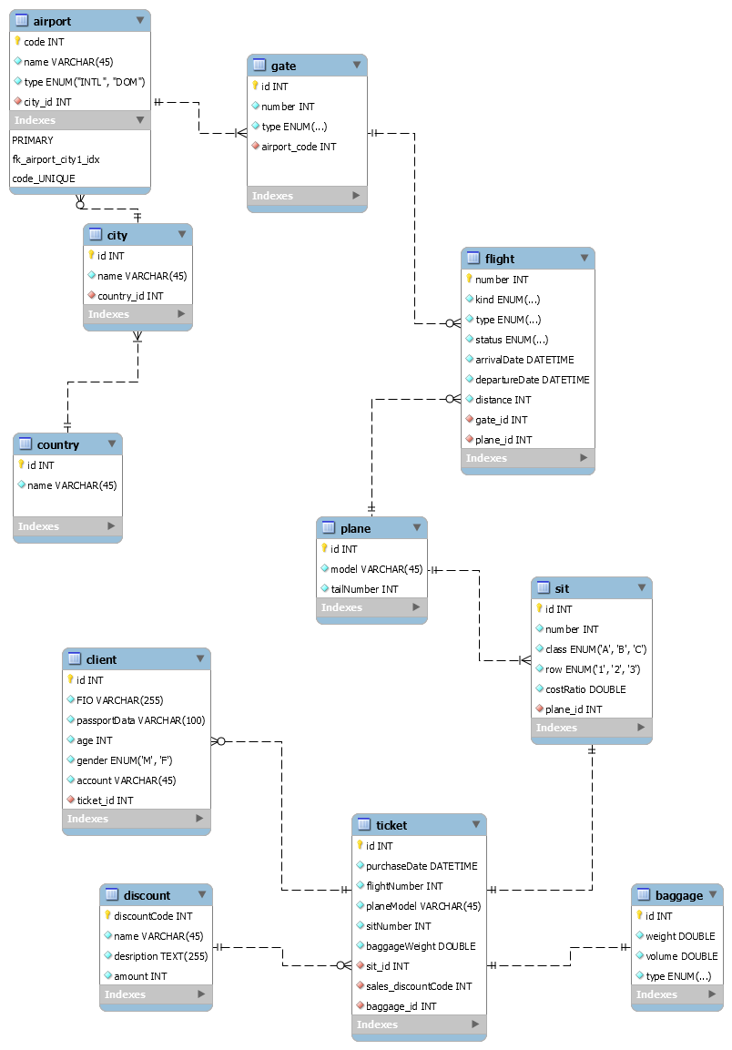

Полное выполнение скрипта (без DROP DATABASE), таблица noimagination тестовая таблица для выполнения операций.

